

**e-Yantra Robotics Competition - 2017**

**Theme and Implementation Analysis – TB**

**<Team ID>**

|  |  |
| --- | --- |
| **Team leader name** | Adithya K |
| **College** | PES University |
| **Email** |  |
| **Date** |  |

**Scope and Preparing the Arena**

**Q1 a. State the scope of the theme assigned to you. (3)**

< Teams should briefly explain in their own words the theme assigned. What in your opinion is the purpose of such an application? You may use figures/diagrams to support your answer.

Answer format: Text - limit: 100 words >

<AKHIL’S ANSWER>

1. **Attach the Final Arena Images. (20)**

< Prepare the arena according to the steps given in section **3: Arena**, of the rulebook. Please follow the arena configuration shown in **Figure 6: Arena with Blocks and Rotating Structure** of the rulebook.

Take four photos of the completed arena from different angles such that the entire arena along with arena components such as Blocks, Rotating Structure etc., are clearly visible in the photos.

Provide images in answer itself.

Answer format: Images >

**Building Modules**

**Q2. Identify the major components required for designing the robotic system for the theme assigned to you. (5)**

1. **MECHANICAL SYSTEM**

Locomotion /ACTUATORS – This system defines how the robot moves. Using this system, you can make your robot move forward, backward, right, left, climb up/down, etc. To accomplish this, we need devices which convert electrical energy into mechanical energy. Such devices are called actuators and some of the actuators used are DC Motors, Stepper Motors, and Servo Motors.

Mechanical arm/grippers - for additional support and to perform tasks like carrying.

2. **ELECTRICAL SYSTEM**

Power Supply System - For a robot to work, we need a power supply. The best way for this is to use a battery or use an SMPS/Eliminator to convert AC to DC and then use it. But voltage is not the only thing that matters while choosing a proper supply. Your power source should also be able to supply sufficient current to drive all the loads connected to it, directly or indirectly.

Sensor System – In order for the robot to interact with the physical world, we need to introduce sensors (which can measure physical parameters like radio waves, IR waves, etc.). These sensor systems provide a feedback from the real world to the digital world (embedded electronics), which are processed and the robot takes the decision accordingly.

3. **CONTROL SYSTEM**

Signal Processing System– The data from the sensors and other electrical and digital signals need to be processed, so that the robot analyses the situation and makes its moves. For this, we introduce electronic components to process the signals. The components can be any analogue/digital device, or even a microcontroller. This is the major governing system of the robot. Every system that is present inside the robot and functioning can be represented in form of a control system (open-loop and closed-loop).

Atmel ATMEGA2560 as Master microcontroller

Atmel ATMEGA8 as Slave microcontroller

**Actuators**

**Q3. List all the actuators present on Firebird V robot. Besides the existing actuators, please mention any additional actuators that may be required for implementing a solution for the theme. (5)**

**1.** **60 RPM DC motors & Caster wheel**

The actuators present on the Firebird already are the two 75 RPM DC motors. The motors are the robot’s means of getting around as they drive the wheels of the robot. The motors can rotate in either direction and hence all movements can be achieved with only 2 motors. The logic table describing all motions is shown below:

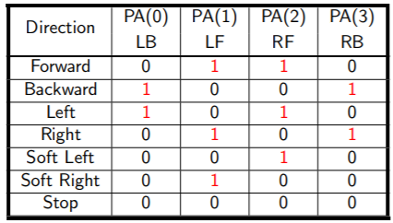a. PA(0) - Left Motor Control

b. PA(1) - Left Motor Control

c. PA(2) - Right Motor Control

d. PA(3) - Right Motor Control

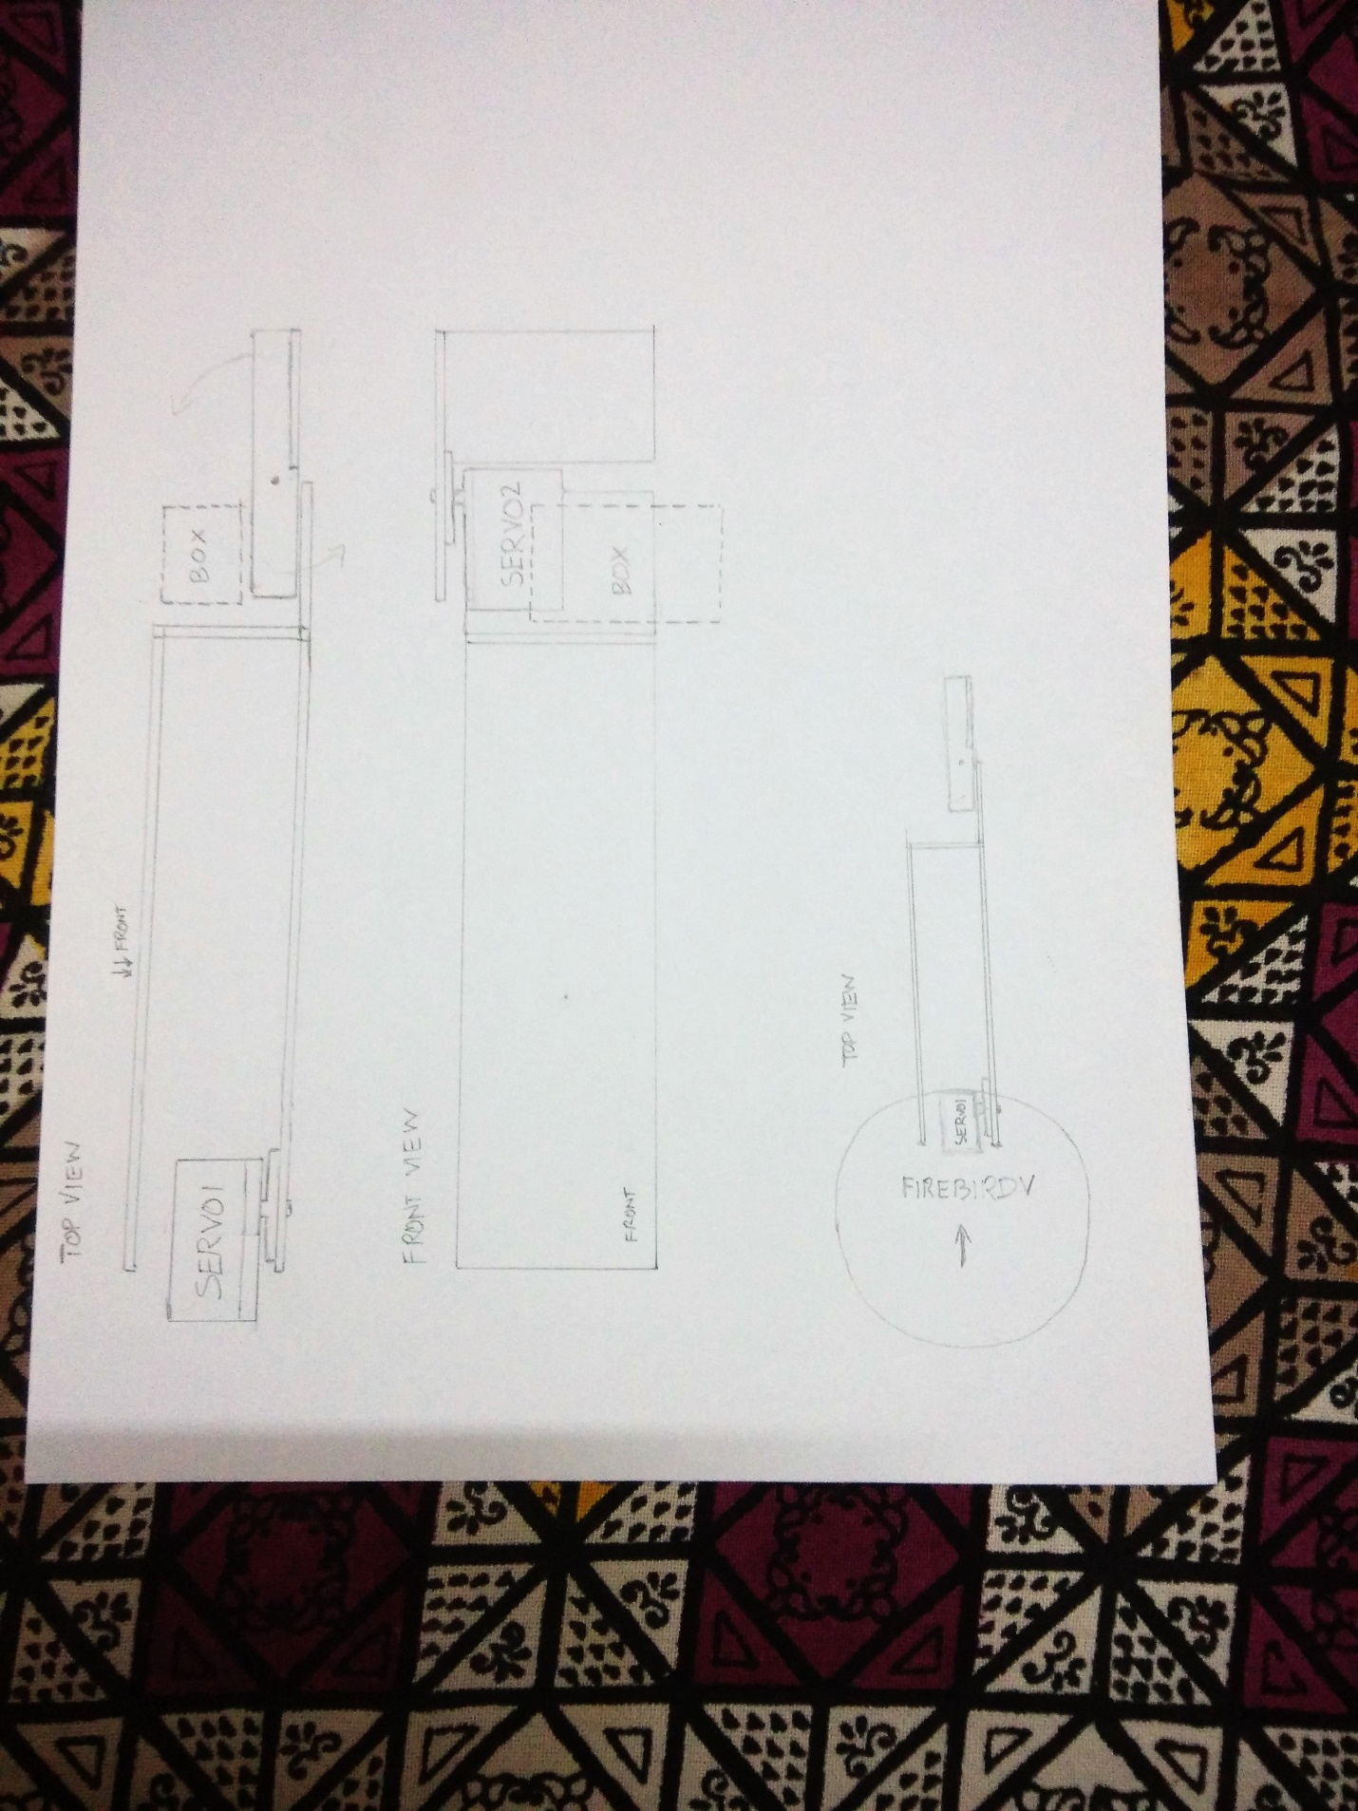

The castor wheel provides support, balance and enables free movement of the bot.

**2. Servo Motors**

We also have to interface two servo motors onto the Firebird. They are required for the arm and its functioning. One motor facilitates movement on the Y-Axis and the other one along the X-Axis.

TOP VIEW

**FRONT VIEW**



**3. Stepper Motor**

We have to use stepper motors to control the rotating structure. This is wirelessly interfaced with the robot using Xbee. It is essential since we require accurate rotations.

**Power Management (2)**

**Q4. Explain the power management system required for a robot in general and for Firebird V robot in particular.**

For most robots, a battery is preferred as the primary power supply over auxiliary sources as:

1. It provides greater mobility.
2. It provides a direct DC source.

The power supply should be able to supply the required voltage and current to the robot at all times.

Fire Bird V is powered by 9.6V rechargeable Nickel Metal Hydride battery pack. The battery voltage can vary between 12V (fully charged) to 8V (discharged).

Servo Motors: 5-10V, 500mA-1A, depending on its application.

DC Motors: 8V to 11.3V depending on the battery's charging state, 600mA. Controlled by the dual motor driver IC L293D.

Logic supply of the ICs, Sharp sensors, LCD etc.: 5V, 400mA supply.

IR proximity sensors, White line sensors: 3.3V, 100mA supply.

**Design Analysis**

**Q5.** **Teams have to design a mechanism for picking and dropping the Blocks into the Rotating Structure.**

1. **Choose an** **option to position the mechanism on the robot and justify your option (4)**
2. **Front 2. Back 3. Right/Left**

**Answer: Front**

For the pathing on the arena given to us, the most efficient position of the arm would be on top of the robot, facing front with respect to it. The arm can be much shorter because the robot can get pretty close to the blocks.

If it were to the side, since the robot can’t move sidewise, a lot more complex rotations/movements have to be considered; or the arm should be very long which makes the idea of having it on the sides impractical.

The arm can be placed at the back without making much of a difference, but for simplicity, we chose the front.

1. **Explain the design of the mechanism and how it is mounted on the robot. (4)**

The arm is mounted on top of the robot, facing front. At the end of the arm, there is an attachment provided to grab the object. The movement of the two parts is controlled using servo motors. The arm can move along the Y-Axis (up and down), while the grabbing mechanism moves along the X-Axis.

The servo controlling the arm is fixed on the body of the robot, and the servo controlling the grabbing mechanism is fixed on the arm.



1. **To design the mechanism for picking and dropping the Blocks, what challenge/s do you expect to face and how you will overcome them? (2)**

1. Insufficient grip on the grabbing mechanism.

Solution: Fix rubber pads or other material with greater frictional properties onto the grabbing mechanism.

2. Insufficient mechanical strength of the arm, that is, the arm is not able to handle the forces generated due to the servo and grabbing mechanism

Solution: Use a stronger material like wood to make the entire mechanism.

3. Glue and tape is not strong enough for holding up the mechanism

Solution: Make holes wherever required and find appropriate screws to screw the parts in place.

**d) Choose the actuator/s you will use to design the mechanism. (2)**

1. **DC-Motor 2. Servo Motor 3. Stepper Motor 4. Others**

**Answer: Servo Motors**

We use servo motors for the mechanism due to the reasons:

1. Easy and sufficiently accurate rotations

2. Its shape (cuboidal vs cubic as in stepper motor) is more desirable and less bulky.

3. It is fast

We don’t use DC Motors due to the fact that we cannot accurately control the angle of rotation.

We don’t use Stepper motors due to its bulkiness, and relatively slower operation compared to the servo motor. The difference between servo and stepper is a trade-off between complexity and certainty in control.

**Environment Sensing**

**Q6. Explain how you will use the following to decide the course of action.**

1. **Sensors**
2. **Placement Sequence and**
3. **Structure Sequence (5)**

**Sensors:**

IR sensors decide the distance of the robot from the box, for the arm mechanism to be able to grab the box.

Proximity sensors decide the distance between the robot and the box before the robot stops. That is, when the robot is close enough to a box, it stops, and the IR sensor decides how much backwards it has to move for the arm to grab the box.

White Line Sensors are essential for the robot’s movement around the map.

**Placement Sequence:**

The placement sequence decides which node has to be visited, in order. Based on which node we need to traverse to, the algorithm changes. For example, if the box is at node 1, and the robot is at the start point, the robot turns left, moves straight, turns left, moves straight, turns right, picks up the box and makes its way to the rotating structure. This order of actions changes for different nodes.

**Structure Sequence:**

The structure sequence decides the order in which the colours are positioned on the rotating disc. Based on which crate has been picked up, the disc rotates to the corresponding colour with the help of stepper motor and the robot places it onto the disc. This order of actions changes for different colour crate picked up.

**Q7. Name the sensors (if any) on Firebird V used to complete the task. If used, describe the placement of these sensors on the robot and briefly explain the reason for their placement. If not, justify not using these sensors. (2)**

The sensors on the robot used in implementing the theme:

1. Up to five IR range sensors covering front half of the robot with range up to 150cm for intelligent navigation. Objects can be detected from a considerable distance.
2. Eight analogue IR proximity sensors for close proximity detection up to distance of 20cm. This enables accurate movements and detection.
3. White line sensors, at the front end. White line sensors are used for detecting white line on the ground surface. White lines are used to give robot sense of localization.

The sensors on the robot not required for implementing the theme:

1. Ultrasonic Range sensors. They perform the same task as that of the IR range sensors.
2. Position encoders. These are not essential since we have no use for the data it provides.
3. Infrared TSOP sensors. These are not essential since we have no use for the data it provides.

**Communication**

**Q8. Explain the synchronization between Firebird V, Rotating Structure and Blender Interface. (8)**

The task begins as instructed, and Firebird moves in accordance with the given sequence. The communication during the entire scenario is described below:

Step 1: The Firebird approaches a block.

Step 2: Instructions (code) to send a signal from the Xbee (on the Firebird) is executed.

This signal also indicates which colour of block is being picked up.

Instructions for the arm are also executed at this point.

Step 3: The Xbee connected to the rotating structure receives this signal, and the structure rotates

to the colour indicated by the signal.

The Xbee connected to the system with blender also receives this signal and the robot in the

blender game also moves to the respective crate and picks up the crate.

Step 4: The robot then makes its way to the rotating structure and places the box in the patrtition.

A signal is sent from the Xbee on the Firebird indicating this action.

Step 5: The Xbee connected to the system with blender receives this signal and the robot in the blender

game moves to the truck, to the respective partition, and places the crate.

Step 6: If the crate being deposited is the last crate, the Xbee send another signal indicating the same.

This signal is received by the blender game and the truck, after the last crate has been loaded,

proceeds to move to the market.

This indicates the end of the task, which is indicated by the buzzer on the Firebird.

**Testing your knowledge (theme analysis and rulebook-related)**

**Q9. Attach the Final Blender Interface Image. (8)**

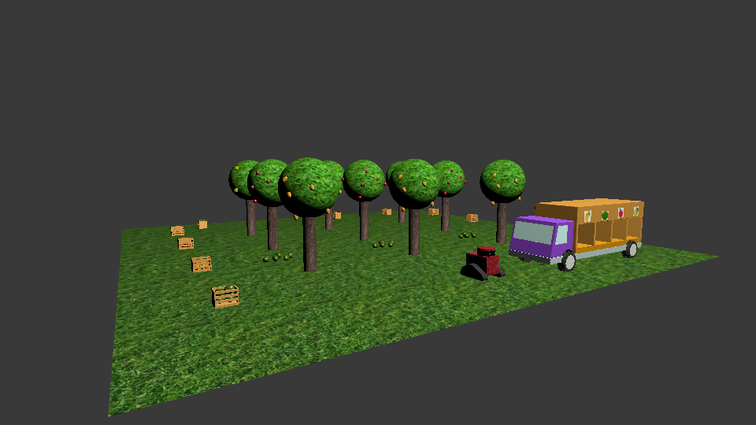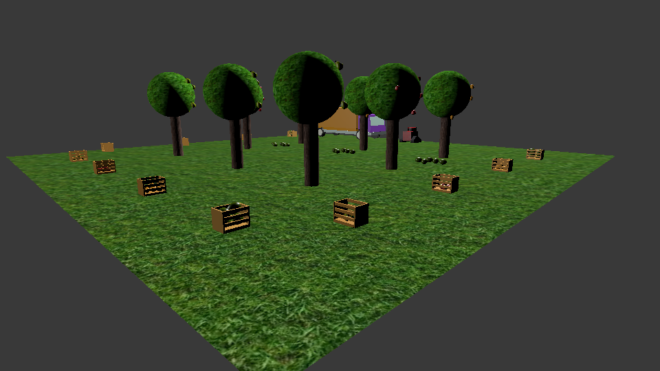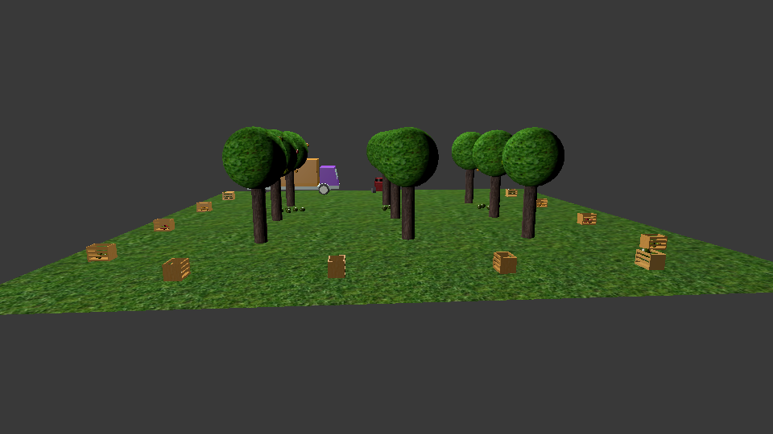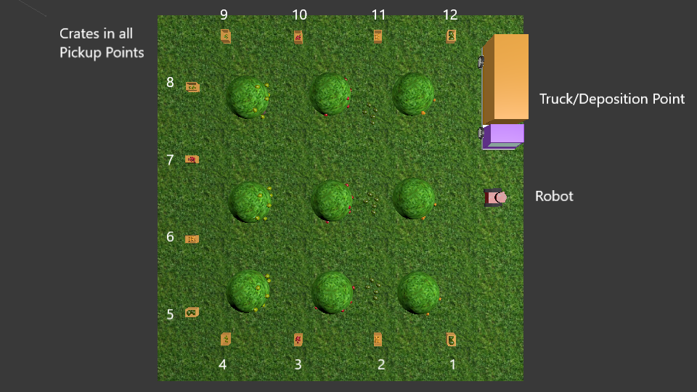

**Q10. Provide the video of Rotating Structure. (7)**

< Prepare the Rotating Structure as per the instructions provided in section **3.3 Preparing and Placing Rotating Structure** and place theRotating Structure as per Structure Sequence given in the example in this section . Write an arduino program to do the following:

1. Move the Rotating Structure in clockwise direction by 90o.
2. Stop for 200msec.
3. Move the Rotating Structure again in clockwise direction by 180o
4. Stop for 200msec.
5. Move the Rotating Structure in clockwise direction by 90o.
6. Stop.

Record the video of Rotating Structure as it performs the above steps.

Upload your recorded video on YouTube. The name of the video should follow the syntax given: If your team Id is "16", you should save the video as eYRC-TB#16_Task3. Your uploaded video should be **Unlisted**. Copy the URL of your video, paste it in the answer.

Answer format: YouTube Link. >

**Q11. Explain in brief the algorithm you will use for navigation of the arena. (08)**

The algorithm starts off with the robot reading the placement sequence. It keeps a count of how many boxes have been picked up and accordingly the next box is selected from the sequence.. The white line sensors define its path and the range sensors tell the bot when to stop.

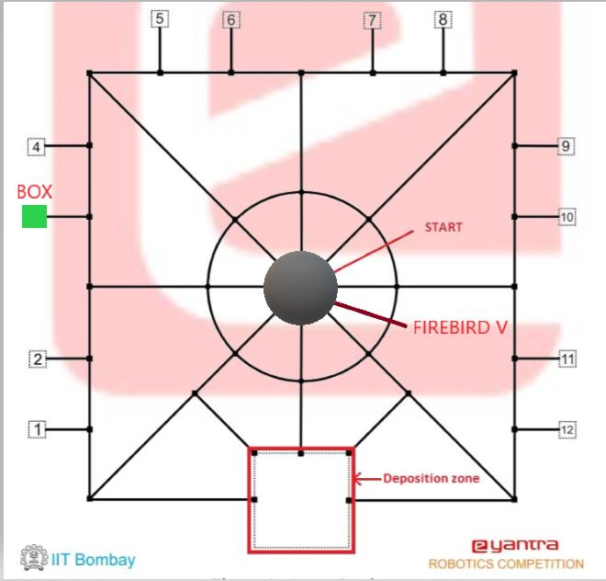Depending on where the current box is on the map, the bot has to take a different sequence of actions. Consider the situation shown here:

The algorithm results in the following sequence of steps:

1. Turn 90’ left.
2. Move forward till end of path
3. Turn 90’ right
4. Move to next node
5. Turn 90’ left
6. Move till close enough to box

At this moment, the box is picked up. Next, to get to the rotating structure:

1. Turn 180’
2. Move till end of path
3. Turn 90’ right
4. Move to next node
5. Turn 90’ left
6. Move till second node (centre)
7. Turn 90’ right
8. Move till close enough to rotating structure (Now the box is put down)
9. Turn 180’
10. Move to next node (Back to starting position)

In this way, all possible placement points will be traversed by the bot.

**Algorithm Analysis**

**Q12. Draw a flowchart illustrating the algorithm you propose to use for Blender.**

**(Include the action undertaken in blender like how robot picks the Crate, drops it in Truck using the information received from Firebird V) (5)**

*Colour of the Crate – Each fruit in blender will be associated with the colours given. Suppose apple is associated with red, then the colour of the crate is red.

Receive Placement Sequence Data

START

Pick Up the Crate on Receiving the Signal.

IF Colour of the Crate* in the Placement Position is

RED

GREEN

Move to Red’s Compartment on the Truck

Move to Green’s Compartment on the Truck

BLUE

YELLOW

Move to Blue’s Compartment on the Truck

Move to Yellow’s Compartment on the Truck

Move to the Placement Position on Receiving the Signal.

Place Crate in the Compartment on Receiving the Signal

Increment Score by 1

NOT EQUAL to total number of boxes

IF Score is

EQUAL to total number of boxes

Move the Truck to the Market

END

**Q13. Draw a flowchart illustrating the algorithm you propose to use for theme implementation. (5)**

NOTE: All the actions in Blender occur as per the flowchart provided in Q12.

FALSE

TRUE

End

Bot Sounds Continuous Buzzer

Go Back to Start Position

If Score= Number of Boxes

Increase the Score by One

Firebird Puts the Box Down. A Signal is sent to Blender to do the same.

Firebird Picks Up the Box. A Signal is sent to Blender to do the same.

Firebird Moves to the Rotating Structure. A Signal is sent to Blender to do the same.

Firebird Moves to the Placement Position. A Signal is sent to Blender to do the same.

Rotating Structure Rotates According to the Information given.

Read Next Placement Sequence. Send the Information to Blender and Rotating Structure.

START

**Challenges**

**Q14. What are the major challenges that you can anticipate in addressing this theme and how do you propose to tackle them? (5)**

Challenges anticipated in addressing the theme in the current phase:

1. Servo Motor management

The major challenge would be to manage the order of operation. Coordination of the code and proper timings should help us tackle with the issues if any.

2. Gripping Mechanism

One of the challenges is to ensure proper picking of the crates and dropping it into desired position without any damage. To do this, accuracy and efficiency is the key. This can be achieved by using the right material, and by running tests for desirable results.

3. Communication

Communication between blender and the Firebird/ Xbee may lead to errors. This should be tackled with the use of proper interfacing and configuration.

4. Efficient traversal across the map

For the robot to traverse all the placement points efficiently, the algorithm should calculate the shortest distance from each stage to the next. This can be achieved by researching and implementing algorithms which enable programmers to do the same.

Challenges anticipated in implementing the theme in the real world scenario:

1. Cost of the robot

The robot might be too pricy for some people. The overall cost can be reduced by fitting the robot with only the absolutely essential components.

2. Difficulty of usage/ malfunctions

Many users might find setting up the robot/ debugging to be hard. This can be resolved by making a very simplistic app for the same, or by having representatives available for help at all times.

3. Varying world conditions

Not all farms will have the same facilities and infrastructure/landscape. The robot should be ruggedly built and powerful to overcome harsh climate and uneven grounds.

4. Areas with little or no consistent electricity

These remote areas where the robot would help immensely can be provided with generators for charging the robot.